

MOBILE DENTAL SUCTION

OPERATION MANUAL

(Please read the operation manual before maintaining or repairing equipment, the manual is only for guidance, our company have the right to improve the design.)

Thank you for choosing our company's GS-M series of mobile dental suction unit! In the first installation and use of our mobile dental suction unit, please make sure to read all the information supplied firstly, in particular the installation information in this manual and other terms mentioned in the note. This will help you to make better use of Greeloy’s products.

Disclaimer
The description of this manual does not mean that Greeloy product specifications and configuration of any description. For the product specifications and configuration, please refer to the related products with Greeloy agreement, packing list, or directly consult the product dealer.

In the preparation for manual process, has sought to correct and complete content, but because of technical and technological advances, relevant laws and regulations changed, Greeloy mobile dental suction machine and operate manual will be changed accordingly. Therefore, we have the right to revise, this manual description of product and the contents of this manual at any time, without notice. Greeloy Medical will continue to constantly improve their products and improve their services.

If you find the actual situation of the products and the instructions are inconsistent when using the instruction book, or you want to get the latest information, or have any questions, please call us or visit our Website.

Limited warranty
If the product comes with the details of Greeloy Medical's service (warranty documents), Greeloy Medical will provide the service according to this detail service. If the product does not come with the Greeloy Medical company's service rules (warranty file), it indicates that your after-sales service will be executed according to the written agreement of product provider and product receiver, it is not suitable for service conditions (warranty documents), and it do not contain any ostensive or implicit warranty, in this situation, you cannot get the after-sales service, if you are willing to accept Greeloy Medical’s product, you should require the organizations or persons who provides you the products to provide you with their service according to commitment.

These products are only in accordance with local laws and regulations of the national and regional sales.

The maximum extent permitted by law, Greeloy Medical will not bear any responsibility for the company in the following cases:

1, Third-party claims against you;
2, Incidental or indirect damages and economic losses;

3, Due to your own configuration and all damages caused by the economic loss;
4, Because you are not required in the environment in this guide use of this product, or any damage and economic loss caused by the failure of this method of operation under the guidance;
5, All damage and economic loss caused by force majeure.

You can call the Greeloy Medical after-sales service telephone number: +86-21 6071 9236

Note: The phone number may be subject to change because of the communications network or other objective factors without notice.

Copyright
This manual was owned and all rights were reserved by the Shanghai Greeloy Medical Instrument Co., Ltd. Other accessories of the product or product documentation, the copyright belongs to the corresponding organization or person owned.

Sign flag
Note: There are likely to lose parts and material document.

Note: That can damage equipment or cause equipment not working properly.

Contents

Brief introduction

- Technical data

- Structure and working principle

- Environmental conditions and installation

- Maintenance

- Troubleshooting

- Electrical schematic diagram

- Packing list

Brief introduction
Thank you for purchasing our mobile dental suction unit. It is our company
well-developed mobile dental suction, with filtration and air & water separator, combine with ergonomic appearance design; this unit can keep powerful suction, stable working performance, also lower working noise.

Information:
Name: Mobile Dental Suction Unit
Model No.: GS-M 300/400
Main configuration: please refer to the enclosed packing list
Main structure: it consists of ring blow, filter, air & water separator, PCB, ect. Scope of application: assisted in the process of dental treatment Production date: please refer to the nameplate
Usage period: 5 years

Safety tips:
- Before connect the power plug, please ensure the power voltage consistent with the named voltage which this unit required.
- Before maintain or repair or clean the unit, please unplug electric wire firstly.
- This unit cannot be used in flammable mixture environment.
- This unit cannot be used in a strong electromagnetic environment; otherwise the unit may not work properly.

Technical data

Data
Model No. | Power (VA) | Max.flow (L/min) | Max. negative pressure (Kpa) | Working noise (dB) | Fuse (A) | Gross weight (kg) | Dimension (mm)
GS-M 300 | 300 | 350 | -12 | 50 | 10 | 29 | 515x395x895
GS-M 400 | 400 | 450 | -12 | 50 | 10 | 30 | 515x395x895

  - Mark meaning
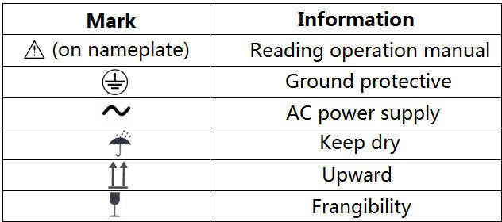

Warning:

Please operate the unit strictly under the named supply voltage, because the unsteady current can cause injuries to the unit.
Please install power voltage regulator when supply voltage is unsteady, and the rated power is no less than 2000VA.

Structure and working principle
  - Unit structure (same for both models)
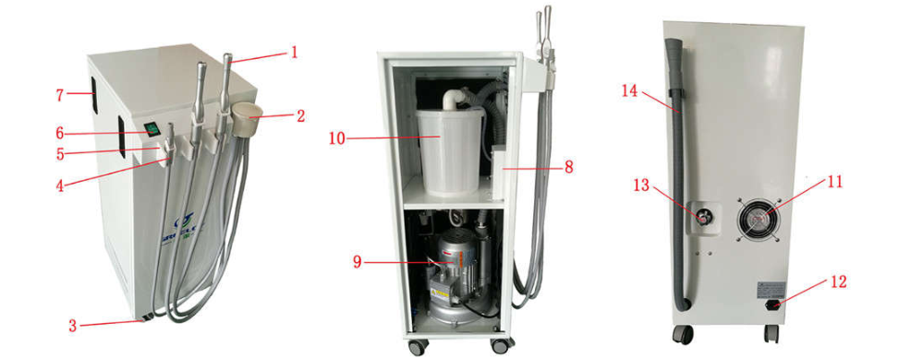
1. High volume suction | 2. Filter | 3. Wheels | 4. Saliva ejector
5. Electric control holder | 6. Power switch | 7. Door lock | 8. Control box
9. Ring blower | 10. (6L) Sewage collector | 11.Cooling fan | 12. Power socket
13. Drainage switch | 14. Sewage pipe

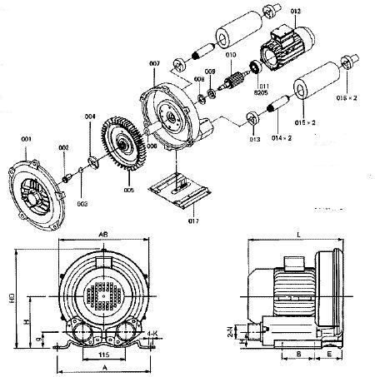
Ring blower structure

001 Wind cover | 006 Bushing block | 011 Bearing | 016 Connector
002 Screw | 007 Wind barrel | 012 Electric motor | 017 Foot
003 Spring-pad | 008 Bearing | 013 Rubber gasket
004 Impeller plate | 009 Bearing block | 014 Core
005 Impeller | 010 Rotor | 015 Flue pipe

  - Working principle
About Ring Blower: Ring blower's impeller contains numerous blades in its edge and it is special designed for a high air pressure. When the impeller is rotating, air between the impeller would be accelerated along the direction of the fan blades and due to rotating movement, after air enters outside air layer, it comes back to the base of the fan blades due to the effect of the differential pressure, the cycle will repeat several times to make the air run spirally so as to increase the pressure. The air will expel quickly because of the pressure there bigger than the pressure in the system when the air runs through the outlet.
About mobile suction unit: Connect to correct electric power supply; take up the suction from electric control holder, suction unit would start to work automatically to suck foreign objects and secretion from patient’s mouth and send to filter. The filter would separate solid matter, dirty blood, secretions, etc., the dirty blood, secretions will be kept in sewage collector, and the solid matter will be kept into filter (Please clean the filter regularly, it is recommended to clean it once a week). In order to make sure clean air flow come into ring blower, and impellers not will be damaged by corrosion, once dirt water kept till half of sewage collector, suction motor would stop to work, cannot create vacuum any more, then, please drain all the dirt water out manually, re-fix the collector well, the suction could start to work again. (Inside of sewage collector, there is the sensor to control liquid level)

Environmental conditions and installation

Transportation and storage:
Ambient temperature range: -40 ° C ~ + 55 ° C Relative humidity range: ≤80%
Atmospheric pressure range: 500hPa~1060hPa
Pay attention when transporting and storing, keep upward and keep dry

Working environment
Ambient temperature range: 10 ° C ~ + 40 ° C Relative humidity range: ≤80%
Atmospheric pressure range: 500hPa~1060hPa

Installation
- Make sure the mobile suction unit is placed on a flat surface, tilt angle is not more than 2°.
- Connect to correct electric power supply, turn on the power switch, the light is on, it means, power supply is correct, the suction can work. Pick up the suction from holder (each one is ok), suction unit would start to work; send the suction back to holder, the suction would stop working about 10 seconds later.
- Try the suction with clean water, once the sewage collector with about 3L water inside, the sensor would send signal to suction pump to stop working.
- Turn off the power switch, keep the sewage pipe into big tank, rotate the drain switch as marked on the tip, and drain out all the dirt water, close the switch.

Maintenance
Regular maintenance can reduce the faults, can keep the mobile suction unit in good working condition and prolong the service life. When cleaning and maintenance, please make sure the operator would wear a mask and waterproof gloves before operation. The specific operation is as follows:

- Clean the suction tubes everyday by sucking clean water twice after use.
- Clean the suction tubes with non-foaming cleaner and disinfectant, do not clean with hot water directly.
- Clean the filter at least two times every month, or maybe the suction power will be weak.
- Check all the wires and air tube, water tube, make sure there is no damage or extrusion before every use.
- Before any clean or maintenance, cut off power supply. All the inner parts cleaning or replacement, please ask service from professional.
- If service life is over 5 years, if any damage, then this unit cannot work anymore. You may contact Greeloy company for recycling or scrapped according to relevant national regulations.

Trouble shooting
 | Problem | Reason | Check
1 | Suction cannot start to work | Didn’t connect to  electric power supply, or supply with problem. | Check the main power supply, and fuse.
2 | Too much noise | Solid particles or debris enter into ring blower. | Open the ring blower, and clean the impeller
3 | Too much shake | Ring blower impeller is damaged or the  impeller is dirty | Open the ring blower, and clean the impeller
4 | Unit get overheat | Low voltage or air inlet blockage | Clean the filter, and check all lines, hoses and  connections
5 | Very weak suction | Air inlet is blocked or leaking from hose | Clean the filter, and check all lines, hoses and connections
6 | Unit get overload | Low voltage | Check the specifications of  the power supply voltage and power cord
Note: If any abnormal with the mobile suction unit, please do not open the device or replace the accessory, please contact the manufacturer or an authorized service provider for repair. Circuit diagrams, parts lists, product descriptions, operating instructions, technical specifications and other useful information are required to be provided by the authorized service technician.

Electrical schematic diagram

Schematic diagram of piping

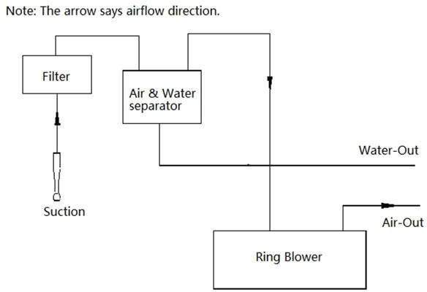

  - Circuit diagram

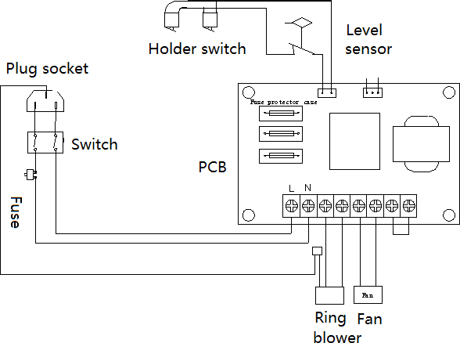

- Packing List

No | Name | Quantity
1 | Suction unit | 1 pc
2 | Power supply wire | 1 pc
3 | Operation manual | 1 pc
4 | Fuse | 2 pcs



